FACULTY OF INFORMATION TECHNOLOGY
IT PROJECT 700 | GROUP 55

EMERGEX
  - Centralized Student Accommodation & Secure Booking Application
PHASE 3 - ANALYSIS
Information gathering, current system, requirements and data models
Supervisor: Thabiso | ThabisoA@richfield.ac.za | Semester 2, 2026
Student no. | Member | Email | Contact | Primary role
402308936 | Tristan Moses | 402308936@my.richfield.ac.za | 0828015082 | Project manager and frontend lead
402411668 | Reenesh Ramawthar | 402411668@my.richfield.ac.za | 0846041521 | Backend and quality engineering
402411227 | Joyce Kamalu | 402411227@my.richfield.ac.za | 0671075365 | Business analysis and documentation
402412304 | Novithan Naidoo | 402412304@my.richfield.ac.za | 0620829186 | Database and backend engineering
402413409 | Thingo Shezi | 402413409@my.richfield.ac.za | 0714299251 | UI/UX and frontend engineering
402111846 | Lungelo Ngwane | 402111846@my.richfield.ac.za | 0642534563 | Testing, deployment and support
Project lead baseline: Tristan Moses | Every member contributes and presents.

Table of Contents
Analysis Phase 4
Information-Gathering Methodology 4
Analysis of the Existing System 4
Weaknesses and Root Causes 5
Data Analysis: Integrity and Constraints 5
Analysis of the Proposed System 6
Functional Requirements 7
Non-Functional Requirements 8
Data Modelling 9
Requirements Validation and Traceability 10
References 11

PHASE 3

Analysis Phase
Analysis validates what the system must do, why current approaches are insufficient and which data and quality rules govern the proposed solution.

Information-Gathering Methodology
The analysis uses triangulation rather than a single source. Documentary analysis covers the module guidelines, Group 55 concept notes, official DHET and NSFAS material, applicable privacy legislation and public competitor information. Structured observation maps the visible steps of searching, enquiring and confirming accommodation. Participatory workshops convert the six team members into representative student, landlord, administrator, analyst, developer and tester viewpoints. Semi-structured interview guides are prepared for future validation with real users, but no unrecorded interview claim is presented as completed evidence in this report.
Table 1. Fact-finding methods
Method | Participants / source | Questions addressed | Output
Document review | Guidelines, proposal, pitch and official sources | What is required academically, operationally and legally? | Rubric map, constraints and evidence register
Structured observation | Public accommodation search and booking journeys | Where does a user change channel, wait or lose status visibility? | Current-state process and weakness list
Participatory workshop | Six group members using assigned stakeholder roles | Which tasks, states and exceptions matter? | Use cases, business rules and priorities
Interview guide | Planned students and landlords | What information builds trust and what causes abandonment? | Validation script for supervisor-approved research
Prototype walkthrough | Team and supervisor | Can each role complete the critical path? | Usability issues, defects and acceptance decisions

Analysis of the Existing System
The relevant current environment is not one system. It includes institution residence processes, private-provider websites, accommodation marketplaces, social-media groups, direct messaging and bank transfers. A student often discovers a property in one channel, requests details in another, signs or sends documents by email and pays directly. Each channel may be individually familiar, but the overall state of the booking is difficult to audit.
DigsConnect is treated as the principal marketplace comparator because its public material describes a South African student-accommodation search and enquiry service, verified listings, direct communication and a booking/facilitation model [4][5]. The analysis does not claim that the competitor is unsafe or featureless. Instead it uses the publicly visible workflow as a baseline and asks how an academic prototype could make evidence categories, response deadlines and booking/deposit states more explicit in one interface.
Table 2. Current-state process analysis
Step | Typical channel | Observed limitation | Consequence
Discover property | Marketplace, social media or institution list | Inventory and filters vary by channel | Students repeat searches and comparisons
Verify legitimacy | Profile, messages, reviews or manual documents | Evidence standards and reviewer identity may be unclear | Trust depends on informal judgement
Inspect property | Photos, visit or separate video link | Media may be incomplete or inconsistent | Remote students cannot assess layout confidently
Enquire | Form, chat, email or WhatsApp | No common response timer or status vocabulary | Student may wait while alternatives disappear
Confirm tenancy | Message and lease exchange | Availability may not update across channels | Double-handling and stale inventory risk
Pay deposit | Direct bank transfer or external gateway | Payment may occur before safe check-in evidence | Dispute and fraud exposure
Move in | Offline inspection and handover | Booking system may not record condition or confirmation | Weak release and dispute evidence

Weaknesses and Root Causes
Table 3. Weakness analysis
Weakness | Root cause | Requirement response
Fragmented journey | Search, communication, evidence and payment are separate | Provide one booking record with visible lifecycle states.
Uneven listing quality | Free-form listings do not enforce a complete evidence set | Require structured attributes and visual-evidence categories before publication.
Slow response uncertainty | Enquiry systems may show that a message was sent but not an operational deadline | Store a 12-hour response deadline and prioritize pending requests.
Deposit exposure | Direct transfer is disconnected from verified check-in | Use a simulated hold/release lifecycle and document production PSP boundary.
Accreditation ambiguity | Status may be stated without stored review evidence | Allow administrator review and visible NSFAS filter.
Excessive personal-data handling | Documents are shared across uncontrolled channels | Minimize data, restrict uploads, validate type and define retention.
Weak accountability | Critical decisions are not consistently timestamped | Write audit events for registration, verification, booking and escrow changes.

Data Analysis: Integrity and Constraints
The central analytical decision is to treat a booking as a controlled stateful transaction, not merely a message. Rent and deposit values are copied into the booking at creation time so later property price changes do not rewrite the historical agreement. Each escrow simulator record has a one-to-one relationship with a booking. Ownership links restrict a landlord to properties they own and a student to bookings they created. Verification timestamps are separate from published status so the system can distinguish review evidence from presentation state.
Table 4. Business data rules
Rule ID | Rule | Enforcement
BR-01 | Every user has one unique email address. | UNIQUE database constraint and registration error handling.
BR-02 | A student number is required for student registration and is unique when present. | Server validation plus nullable UNIQUE column.
BR-03 | Only active accounts may authenticate. | Login query and current-user lookup check status.
BR-04 | Only verified, published properties appear in search. | Search WHERE clause requires status and verified_at.
BR-05 | Rent must be positive and deposit cannot be negative. | Database CHECK constraints plus numeric input validation.
BR-06 | A booking belongs to one student and one property. | Foreign keys and ownership queries.
BR-07 | Each booking has exactly one escrow simulator record. | Unique booking_id in escrow_transactions; transaction at booking creation.
BR-08 | Only pending standard requests may be approved or rejected. | Server-side status transition guard.
BR-09 | Deposit hold is available only after approval. | Student dashboard checks booking and escrow states.
BR-10 | Release occurs only after a held deposit and check-in confirmation. | Transactional state guard and audit event.
BR-11 | Uploaded demo files must be PDF, JPEG or PNG and at most 5 MB. | Fileinfo MIME allow-list, size check and random stored name.
BR-12 | Only administrators verify landlords, properties and documents. | Role gate and audited update actions.

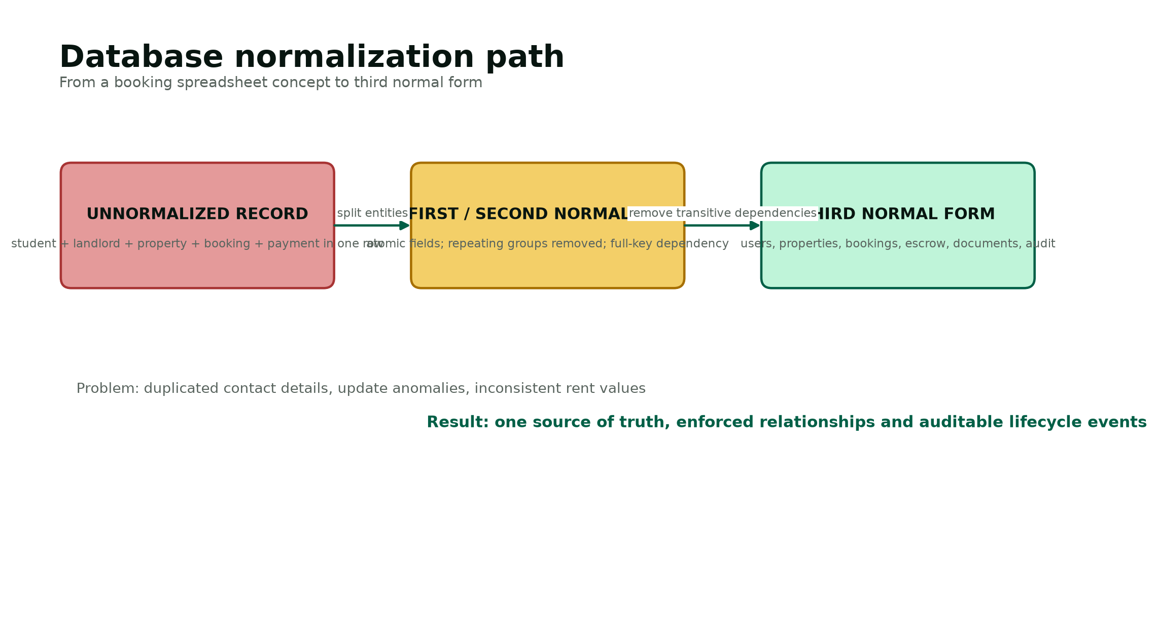
Figure 1. Normalization analysis that removes duplication and update anomalies.

Analysis of the Proposed System
The proposed system is a responsive web application with a public discovery layer and three protected role dashboards. Visitors browse published properties and safety guidance. A student account creates bookings and documents, a landlord account manages only its own property requests, and an administrator account controls verification. The application service layer validates every request, applies authorization, changes database state inside transactions where necessary and creates audit evidence. The MySQL layer enforces the relationships that remain valid even if an application page contains a defect.
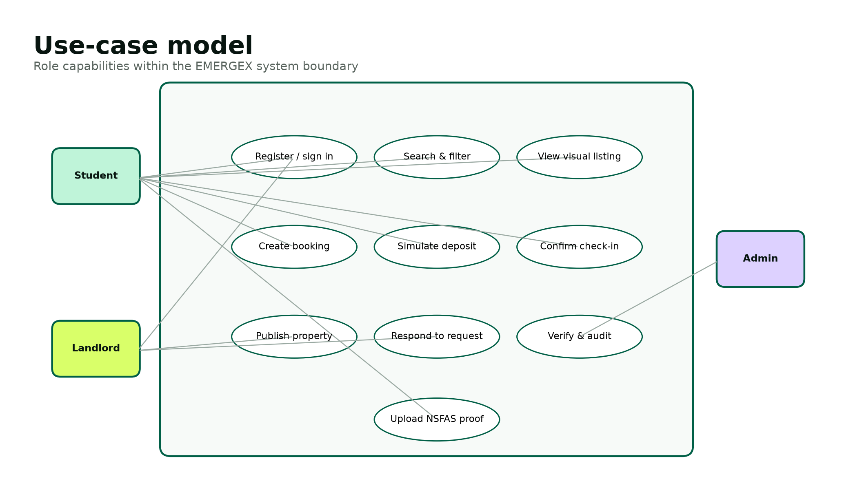
Figure 2. Role-based use-case model for the proposed system.

Functional Requirements
Table 5. Functional requirements specification
ID | Requirement | Priority
FR-01 | Register a student with name, email, phone, student number and compliant password. | Must
FR-02 | Register a landlord without granting verification automatically. | Must
FR-03 | Authenticate an active account and rotate its session identifier. | Must
FR-04 | End an authenticated session and expire the session cookie. | Must
FR-05 | Display only verified, published property listings to visitors. | Must
FR-06 | Search listings by title, city, suburb or nearby institution. | Must
FR-07 | Filter listings by maximum price, NSFAS status and Instant Book. | Must
FR-08 | Display rent, deposit, availability, address, amenities and trust badges. | Must
FR-09 | Display visual evidence categories for walkthrough, floor plan and 360 tour. | Should
FR-10 | Create a standard booking request for an authenticated student. | Must
FR-11 | Store a 12-hour response deadline for a standard request. | Must
FR-12 | Auto-approve eligible Instant Book requests. | Must
FR-13 | Prevent a non-student from creating a student booking. | Must
FR-14 | Allow a landlord to view requests for owned properties only. | Must
FR-15 | Allow a landlord to approve or reject a pending request. | Must
FR-16 | Prevent transitions from a non-pending request. | Must
FR-17 | Create one escrow simulator record with every booking. | Must
FR-18 | Allow a student to simulate deposit hold only after approval. | Must
FR-19 | Allow release only after held status and check-in confirmation. | Must
FR-20 | Display booking and deposit milestones on the student dashboard. | Must
FR-21 | Upload demo NSFAS evidence using an approved file type and size. | Should
FR-22 | Allow an administrator to approve or reject uploaded evidence. | Must
FR-23 | Allow an administrator to verify a landlord. | Must
FR-24 | Allow an administrator to verify and publish a property. | Must
FR-25 | Write audit events for critical state changes. | Must
FR-26 | Show administrator totals for users, properties, bookings and simulated held amount. | Should
FR-27 | Provide a local command-line database installer and seed data. | Must
FR-28 | Provide clear empty and database-not-installed states. | Should
FR-29 | Provide responsive navigation and form layouts. | Must
FR-30 | Disclose that no real funds are processed. | Must

Non-Functional Requirements
Table 6. Non-functional requirements specification
ID / category | Requirement
NFR-01 Security | All database values originating from a user shall be bound through prepared statements.
NFR-02 Security | Passwords shall be stored only as one-way password_hash outputs and verified with password_verify.
NFR-03 Security | All state-changing forms shall validate a session-bound CSRF token.
NFR-04 Security | The server shall enforce role and record ownership; hidden buttons are not authorization.
NFR-05 Privacy | Only data necessary for account, verification and booking shall be collected in the prototype.
NFR-06 Privacy | The academic prototype shall use demo documents and define deletion after assessment.
NFR-07 Performance | A seeded listing search should complete within two seconds on a local XAMPP device.
NFR-08 Availability | The local demonstration shall run without internet access after installation.
NFR-09 Usability | Critical actions and statuses shall use plain language and remain visible at mobile widths.
NFR-10 Accessibility | Pages shall use semantic headings, labels, keyboard-accessible controls and sufficient contrast.
NFR-11 Reliability | Booking plus escrow creation and hold/release updates shall be atomic database transactions.
NFR-12 Maintainability | Configuration, shared security functions, assets, database scripts and tests shall be separated.
NFR-13 Portability | The application shall run on PHP 8.1+ with PDO MySQL and Fileinfo in XAMPP.
NFR-14 Auditability | Critical events shall identify action, actor, time, entity and IP address when available.
NFR-15 Recoverability | The database shall be restorable from versioned schema/seed scripts and operational backups.

Data Modelling
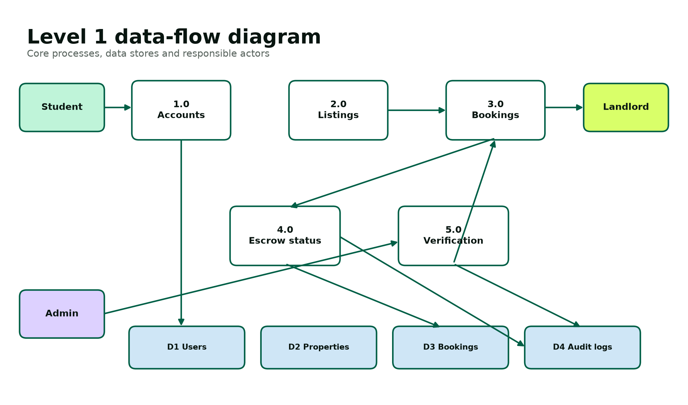
Figure 3. Level 1 data-flow model for the proposed system.
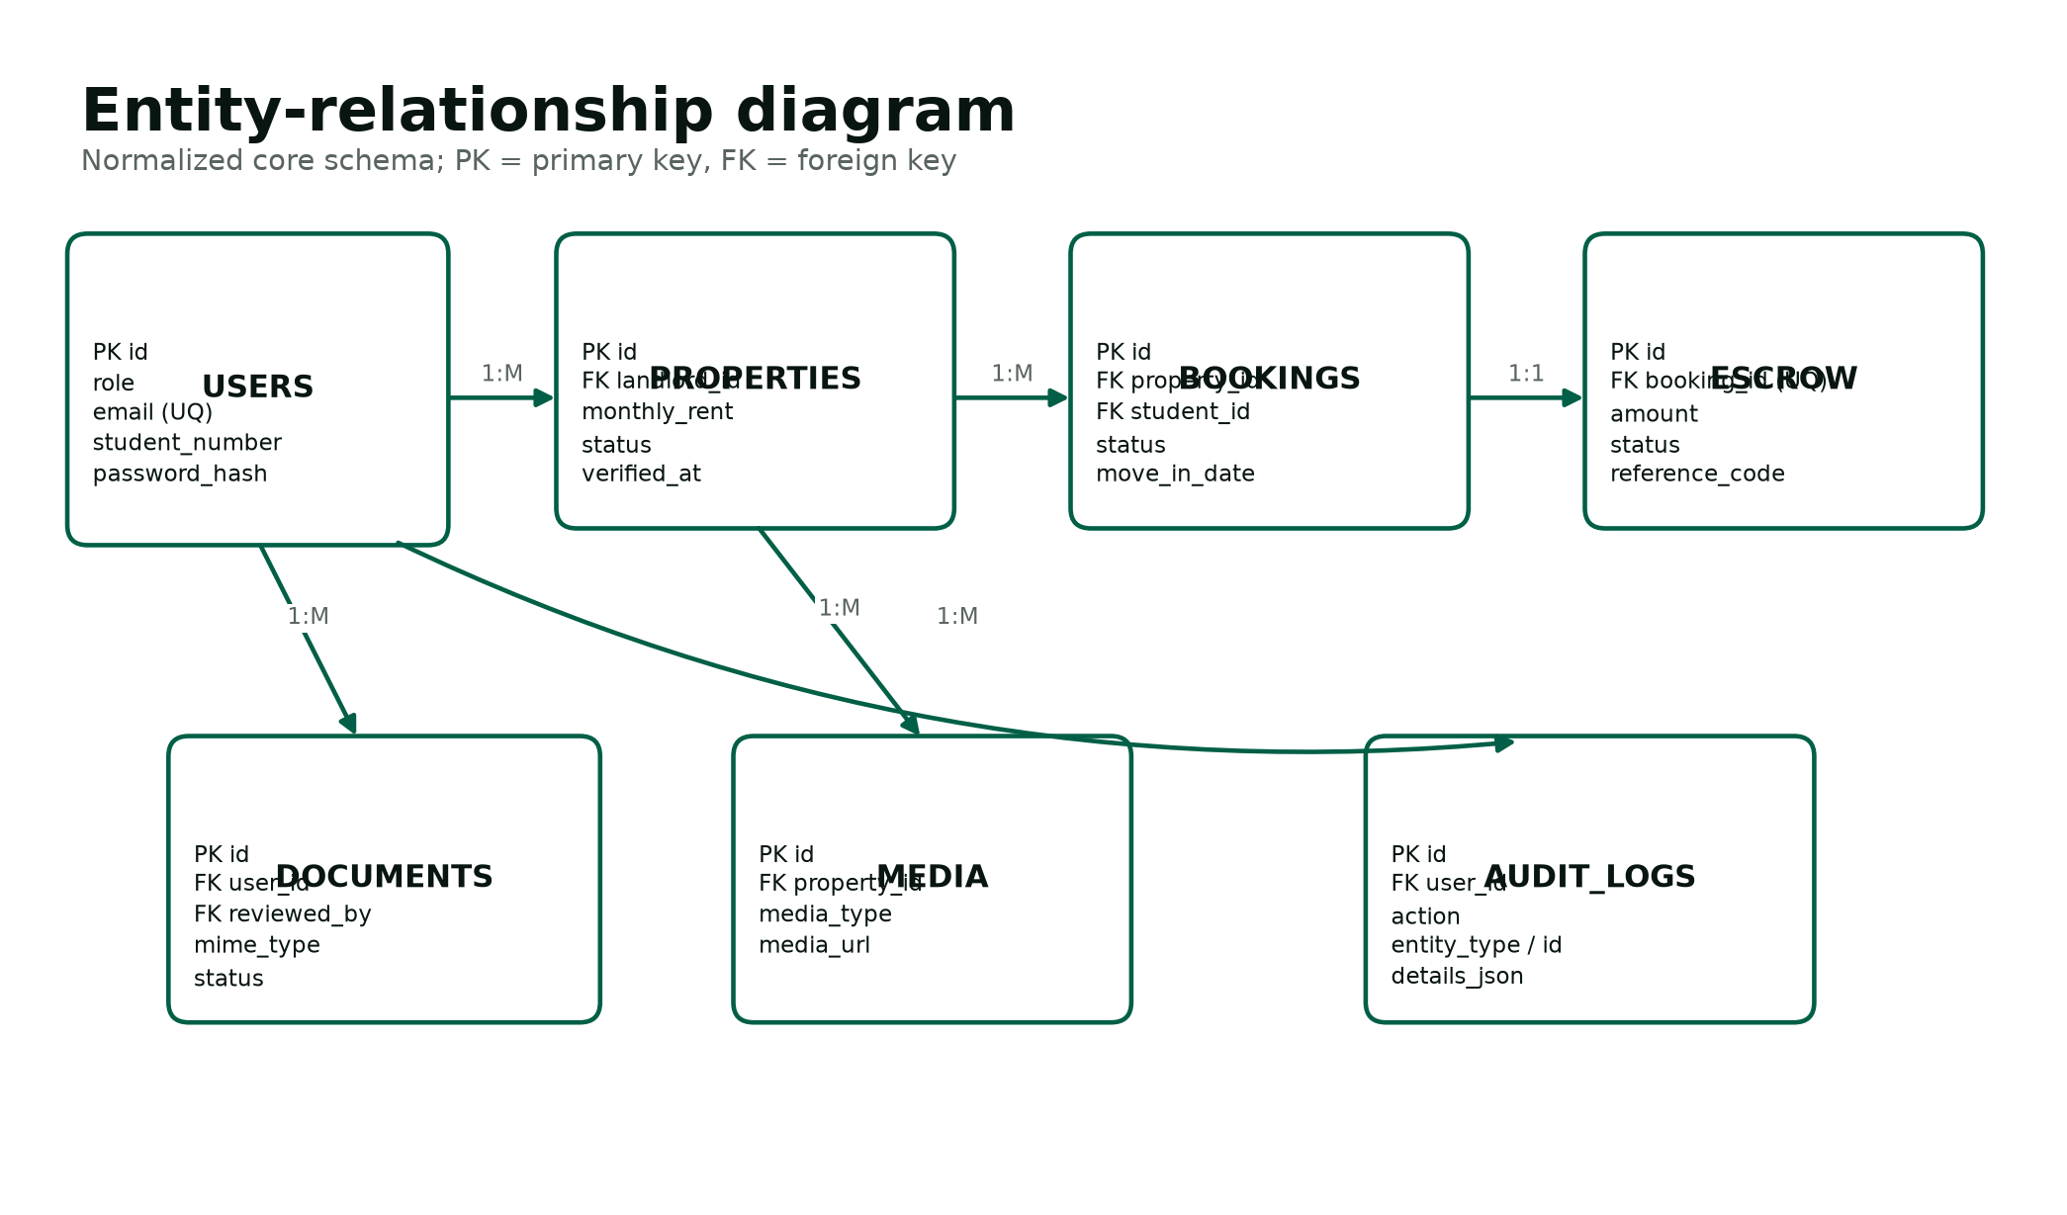
Figure 4. Entity-relationship model for the normalized database.
The data-flow model separates account, listing, booking, escrow and verification responsibilities. The ERD then allocates persistent state to seven tables. Users is the common identity source; role-specific behaviour is enforced in application logic. Properties reference the landlord owner. Bookings reference the selected property and student and capture price at the time of request. Escrow transactions record the simulated financial lifecycle. Documents preserve review metadata without exposing stored file names as public links. Audit logs remain intentionally generic so new critical actions can be recorded without changing the schema.

Requirements Validation and Traceability
Table 7. Requirements traceability sample
Requirement | Design element | Implementation location | Verification
FR-05 Verified listing search | Published + verified property rule | public/properties.php | ST-05 / ST-06
FR-11 Response deadline | Booking response_deadline | public/book.php | ST-14
FR-17 One escrow per booking | UNIQUE booking_id and DB transaction | schema.sql + book.php | DB-04 / ST-18
FR-18 Deposit hold guard | Booking state machine | public/dashboard.php | ST-19 / SEC-08
FR-21 Validated upload | Upload allow-list and protected folder | dashboard.php + .htaccess | SEC-11 to SEC-15
FR-23 Administrator verification | RBAC and audit control | public/admin.php | ST-29 / SEC-06
NFR-02 Password protection | Password API design | register.php + login.php | SEC-01 / SEC-02
NFR-11 Atomic updates | InnoDB + transactions | book.php + dashboard.php | DB-03 / ST-20

Validation uses three questions for every requirement: Is it necessary for a stakeholder or rubric item? Is it unambiguous enough to design and test? Can the delivered system demonstrate objective evidence? Requirements that fail a question are revised, deferred to future scope or marked as a production dependency rather than being described as implemented.

References
[1] Department of Higher Education and Training. Report on the Ministerial Committee for the Review of the Provision of Student Housing at South African Universities (2011). https://www.dhet.gov.za/ResearchNew/39.%20Student%20housing%20at%20South%20African%20universities.pdf
[2] Department of Higher Education and Training. Student Housing Symposium keynote address (2016). https://www.dhet.gov.za/SiteAssets/Minister%20Speech%202016/Student%20Housing%20Symposium%20Minister%20Speech%2021%20July%202016.pdf
[3] National Student Financial Aid Scheme. Registering accommodation properties and student accommodation guidance. https://nsfas.org.za/content/studentacom.html
[4] DigsConnect. Student accommodation marketplace and how-it-works pages (accessed August 2026). https://www.digsconnect.com/
[5] DigsConnect. Terms and conditions, booking process and landlord facilitation fee (accessed August 2026). https://www.digsconnect.com/terms-and-conditions/
[6] Republic of South Africa. Protection of Personal Information Act 4 of 2013. https://www.justice.gov.za/legislation/acts/2013-004.pdf
[7] PHP Documentation. password_hash and password_verify guidance. https://www.php.net/manual/en/function.password-hash.php
[8] PHP Documentation. PDO::prepare and parameter binding. https://www.php.net/manual/en/pdo.prepare.php
[9] OWASP Cheat Sheet Series. Authentication and Session Management guidance. https://cheatsheetseries.owasp.org/cheatsheets/Authentication_Cheat_Sheet.html
Project source: IT PROJECT GUIDELINES SEMESTER 2 2026.pdf and the original Group 55 Phase 1 / EMERGEX pitch documents.

